**PIZZA SALES ANALYSIS (SQL QUERRY)**

**KPI**

**1. Total Revenue: The sum of the total price of all pizza orders.**

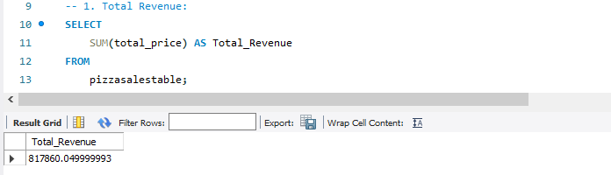

**2. Average Order Value: The average amount spent per order, calculated by dividing the total revenue by the total number of orders.**

**Because there are repeated orders, we will use distinct**

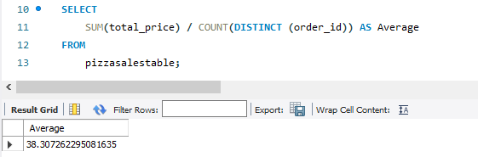

**3. Total Pizzas Sold: The sum of the quantities of all pizzas sold.**

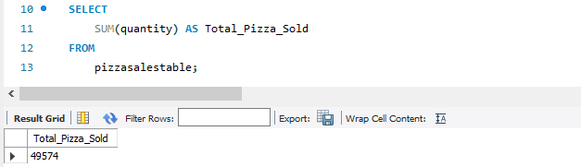

**4. Total Orders: The total number of orders placed.**

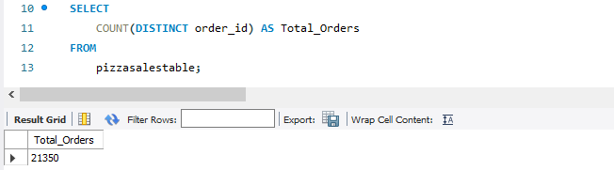

**5. Average Pizzas Per Order: The average number of pizzas sold per order, calculated by dividing the total number of pizzas sold by the total number of orders.**

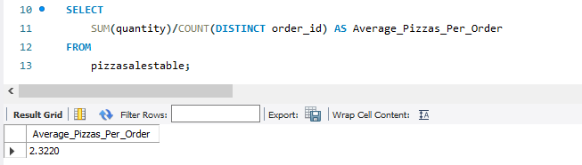

**CHARTS REQUIREMENT**

**1. Daily Trend for Total Orders: Create a bar chart that displays the daily trend of total orders over a specific time period. This chart will help us identify any patterns or fluctuations in order volumes on a daily basis.**

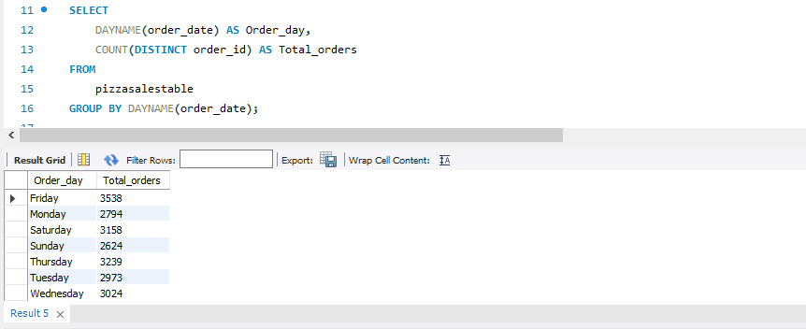

The analysis reveals that the peak order activity occurred on Fridays, while the lowest order volume was observed on Sundays. This insight provides valuable information regarding the daily variations in order volume.

**2. Monthly Trend for Total Orders: Create a line chart that illustrates the hourly trend of total orders throughout the day. This chart will allow us to identify peak hours or periods of high order activity.**

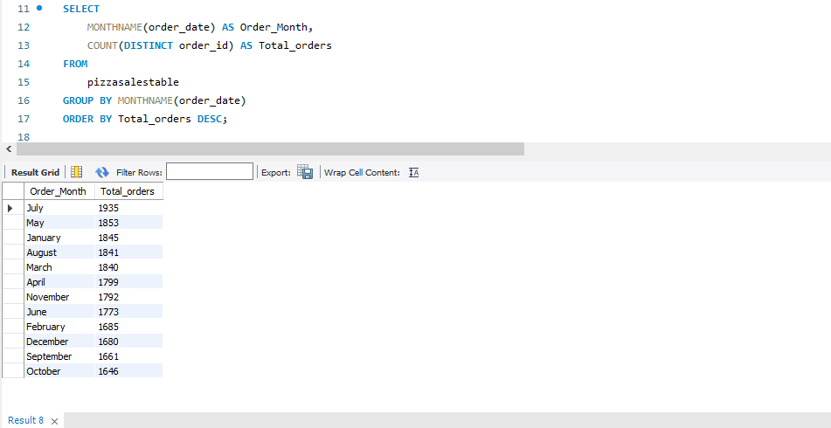

From the above, the analysis reveals that the peak order activity occurred in July, while the lowest order volume was observed in October. This insight provides valuable information regarding the Monthly variations in order volume.

**3. Percentage of Sales by Pizza Category: Create a pie chart that shows the distribution of sales across different pizza categories. This chart will provide insights into the popularity of various pizza categories and their contribution to overall sales.**

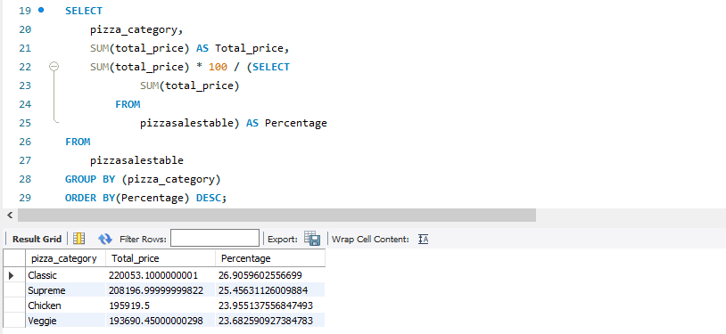

In the analysis depicted in the provided image, it is evident that the classic pizza category boasts the highest percentage of sales, while the Veggie category exhibits the lowest percentage of sales. This observation provides valuable insights into the category-wise performance, delineating the best-selling and least-selling categories.

**4. Percentage of Sales by Pizza Size: Generate a pie chart that represents the percentage of sales attributed to different pizza sizes. This chart will help us understand customer preferences for pizza sizes and their impact on sales.**

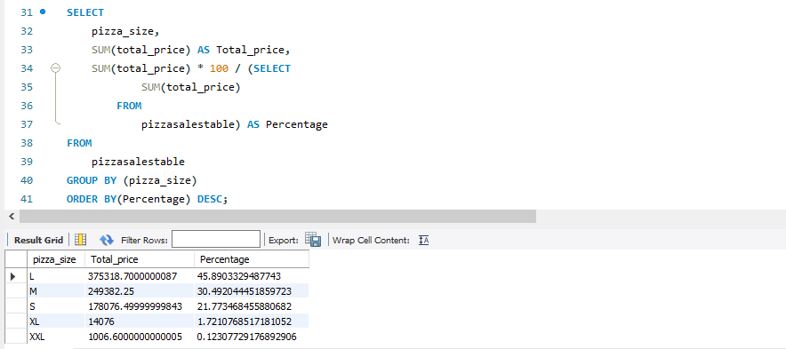

In the analysis presented in the image above, it is evident that the Large category of pizza commands the highest percentage of sales, closely followed by the Medium category, while the Extra-Extra Large category exhibits the lowest percentage of sales. This insight enhances our understanding of the sales performance across different size categories.

**5. Total Pizzas Sold by Pizza Category: Create a funnel chart that presents the total number of pizzas sold for each pizza category. This char will allow us to compare the sales performance of different pizza categories.**

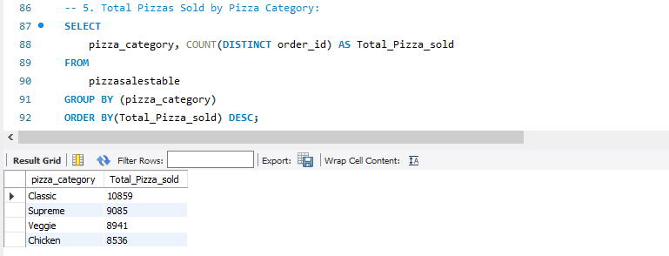

Inference drawn from the query in the figure above reveals that the Classic Pizza category achieved the highest sales volume, whereas the Chicken Pizza category recorded the least sales. This analysis provides valuable insights into the aggregate pizza sales across different categories, aiding in informed decision-making regarding product performance and strategic considerations.

**6.Top 5 Best Sellers by Revenue, Total Quantity and Total Orders, Create a bar chart highlighting the top 5 best-selling pizzas based on the Revenue, Total Quantity, Total Orders. This chart will help us identity the most popular pizza options.**

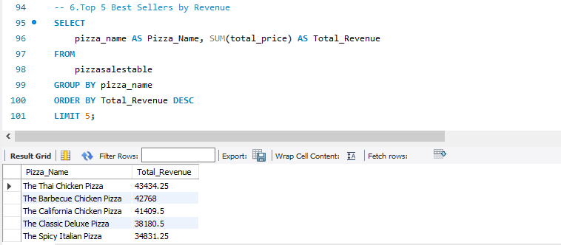

Based on the query results depicted in the image above, it is evident that the top 5 best-selling pizzas, ranked by revenue, are led by Thai Chicken Pizza, followed by Barbecue Chicken Pizza, and subsequently, others in descending order of total revenue.

**Top 5 Best Sellers by Total Quantity**

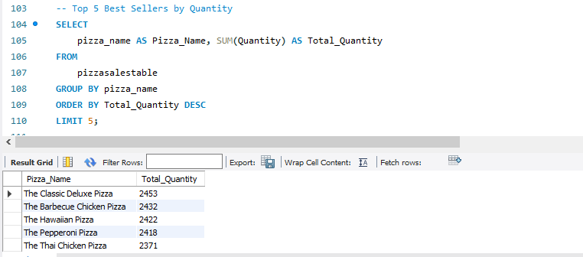

**Top 5 Best Sellers by Total Orders**

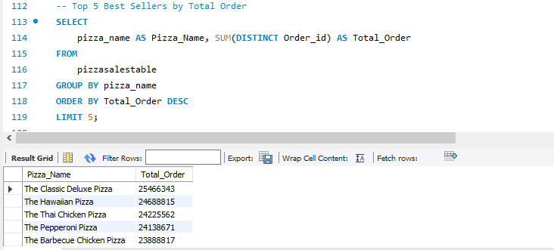

**7. Bottom 5 Best Sellers by Revenue, Total Quantity and Total Orders. Create a bar chart showcasing the bottom 5 worst-selling pizzas based on the Revenue, Total Quantity Total Orders. This chart will enable us to identify underperforming or less popular pizza options.**

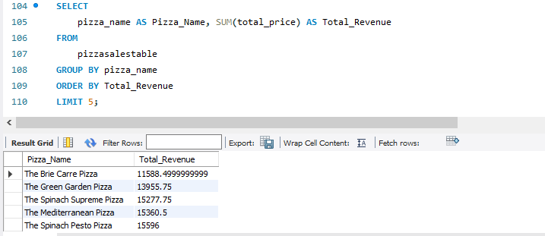

Based on the query results depicted in the image above, it is evident that the 5 bottom worst-selling pizzas, ranked by revenue, are led by The Brie Carre Pizza, followed by The Green Garden Pizza, and subsequently, others in descending order of total revenue.

**Bottom Top 5 Best Sellers by Total Quantity**

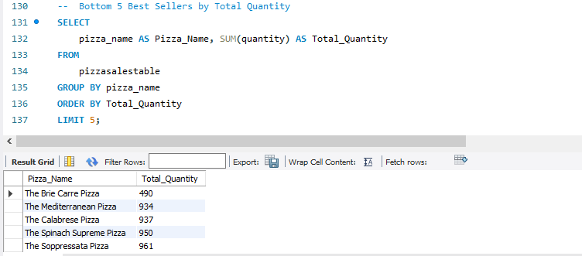

**Bottom Top 5 Best Sellers by Total Orders**

